

C O N F I D E N T I A L

MAISHA TRANSPORT CO. LTD
B U S I N E S S P L A N

COUNT ON OUR SERVICE

PREPARED NOVEMBER 2022

Contact Information
Jumbe Samson
jumbe@maishatransport.co.tz KINONDONI
Dar es Salaam, 34341 Tanzania
+255787268710

MAISHA TRANSPORT COMPANY LIMITED 1

Executive Summary

Opportunity
Challenge

Following the total shift of TANESCO demand to spun pre-stressed concrete poles from treated trees poles, the Tanzania Concrete Poles Manufacturing Company Limited a subsidiary of TANESCO called for tender on Joint Venture to establish concrete poles manufacturing factories to meet ever increasing demand to replace the phased out treated treed poles in Tanzania. Our Company became one of successful tenderers and signed a JVA with TCPM Co. Ltd on 27th September, 2024 to establish a factory at Shinyanga Municipality.
Given the investment needed as per JVA, our Company is funding the project 100% hence the requirement to secure a loan from reputable financial institution or bank.

Solution

MTCL is a company established to venture in transportation, logistics and construction engineering. We have strived as company to venture our investment on acquiring trucks, trailers and tankers for transportation, warehouses and loading equipments for logistics; and various construction machinery and equipments for construction engineering business.
The fact that we have successfully managed to transform our businesses to sustainabilitz level which is credible to diversification to another business venture, without any hesitation based on the projection on resultant income from the concrete pole maufacturingJVA we are very optimistic of the bright future.

Market

As per ratification of the JVA, the established factory at Shinyanga will cater for the western zone market which given the effective demand as per TANESCO figures and our two lines factory to start with will not meet the demand. It is therefore in our future plan to add the third line of manufacturing plant.

CONFIDENTIAL - DO NOT DISSEMINATE. This business plan contains confidential, trade-secret information and is shared only with the understanding that you will not share its contents or ideas with third parties without the express written consent of the plan author.

MAISHA TRANSPORT COMPANY LIMITED

Competition

Given the market pattern as per JVA, we do not expect any competition for the first five years as per demand projections in the western zone which comprises Shinyanga, Tabora, Kigoma and Katavi regions.

Why Us?

Our company is among the credible establishments managed by local Tanzanians aspiring to be part and parcel of industrialization vision of our country. Give us opportunity, you will never regret. We are a value for money oriented company.

CONFIDENTIAL - DO NOT DISSEMINATE. This business plan contains confidential, trade-secret information and is shared only with the understanding that you will not share its contents or ideas with third parties

Expectations
Forecast

Our plan is to start manufacturing by 1st July, 2025 after importation of the machines, installation and commissioning.
Our financial forecast are as summarized hereunder:

Financial Highlights by Year
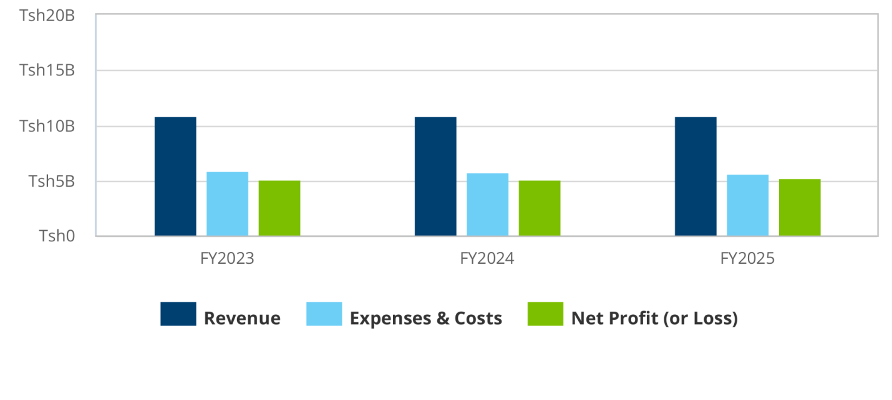

CONFIDENTIAL - DO NOT DISSEMINATE. This business plan contains confidential, trade-secret information and is shared only with the understanding that you will not share its contents or ideas with third parties without the express written consent of the plan author.

MAISHA TRANSPORT COMPANY LIMITED 4

Financing Needed

The company is expected to invest around Tsh 7,100,000,000/= in capital to cover acquisition of land for factory construction, importation of manufacturing machines and equipments, factory construction cost, operating expenses and overheads. Given the projection of cash flows for the first five years, the investment is economically viable to secure a loan.

CONFIDENTIAL - DO NOT DISSEMINATE. This business plan contains confidential, trade-secret information and is shared only with the understanding that you will not share its contents or ideas with third parties without the express written consent of the plan author.

MAISHA TRANSPORT COMPANY LIMITED 5

Opportunity

Problem & Solution
Problem Worth Solving

The phasing out of the TANESCO treated tree poles for electricity distribution countrywide and replacement of concrete poles has provided an opportunity to our company to invest in concrete poles manufacturing factory to cater for the already existing demand of concrete poles

Our solution

We have signed a Joint Venture Agreement with Tanzania Concrete Poles Manufacturing Company Limited which has guaranteed a sustainability of the market for the period of fifteen years.

Target Market
The target market is the replacement of treated tree poles and new distribution lines of electricity in western zone of the country.

CONFIDENTIAL - DO NOT DISSEMINATE. This business plan contains confidential, trade-secret information and is shared only with the understanding that you will not share its contents or ideas with third parties without the express written consent of the plan author.

MAISHA TRANSPORT COMPANY LIMITED 6

Competition
Current alternatives

We are not expecting any competition in our market area of jurisdiction given the JVA execution.

Our advantages

We are a result oriented company with vast experience in long term investments. We have been very successful in investing in business research, market survey and feasibility study of our business undertakings.

CONFIDENTIAL - DO NOT DISSEMINATE. This business plan contains confidential, trade-secret information and is shared only with the understanding that you will not share its contents or ideas with third parties without the express written consent of the plan author.

MAISHA TRANSPORT COMPANY LIMITED 7

MAISHA TRANSPORT COMPANY LIMITED 8

Operations
Locations & Facilities

All business activities of the company will be conducted through centralized operation system at the factory in Nhelegani, Shinyanga municipality

Technology, machinery & equipments

We have entered in agreement with a Chinese company Shandong Haiyu Industrial Group Co. Ltd to supply concrete poles plant which meets international standard in terms of safety and efficiency, designed to best suit the industrial/environment standard in Africa using the modern technology.

CONFIDENTIAL - DO NOT DISSEMINATE. This business plan contains confidential, trade-secret information and is shared only with the understanding that you will not share its contents or ideas with third parties without the express written consent of the plan author.

MAISHA TRANSPORT COMPANY LIMITED 9

Milestones & Metrics
Milestones Table

Milestone | Due Date | Who's Responsible | Details
Securing Fund | Dec 01, 2024 | Board of Directors & shareholders | BoD &management will be
 |  |  | required to process all
 |  |  | document relevant to
 |  |  | secure financial facility
 |  |  | from bank and all
 |  |  | relevant funds required
 |  |  | in the performance of
 |  |  | this business venture.
Mobilizing resources, Factory Building Permit acquisition & Importation of machines | Nov 01, 2024 | Directors & management team | The Board of Directors and Management Team to mobilize all relevant resources required, acquire a factory building permit & finalize negotiation on importation of the machines from China
commencement of | July 01, 2025 | company and | the management team
business operation |  | management team, | will start business
 |  |  | operation and all
 |  |  | operation will be
 |  |  | conducted within a
 |  |  | specified Key
 |  |  | performance indicator
 |  |  | KPI

CONFIDENTIAL - DO NOT DISSEMINATE. This business plan contains confidential, trade-secret information and is shared only with the understanding that you will not share its contents or ideas with third parties without the express written consent of the plan author.

MAISHA TRANSPORT COMPANY LIMITED 10

Company

Overview
Company history

MAISHA TRANSPORT COMPANY LIMITED is a private liability company incorporated in Tanzania with registration number 138216 dated 2017. We have successful grown and been able to benchmark ourselves among a few indigenously owned Tanzanian companies engaged in Transportation, infrastructure development projects and logistics management. We are registered with Contractors Registration Board (CRB) and we are also members of Tanzania TRUCKS Owners Association (TATOA)

Team
Management team

Our management team comprise the of skilled personnel with long time experience in transportation and logistics business; and construction engineering activities. We have a set of core values and code of conduct to deal with increasing transport efficiency in reducing time of delivery of goods and development of infrastructure capable of scaling up to large geographical area for industrial and economical enhancement. Also we have various KPI to evaluate the performance of the company employees and time framework to perform all assigned project.

CONFIDENTIAL - DO NOT DISSEMINATE. This business plan contains confidential, trade-secret information and is shared only with the understanding that you will not share its contents or ideas with third parties without the express written consent of the plan author.

MAISHA TRANSPORT COMPANY LIMITED 1

CONFIDENTIAL - DO NOT DISSEMINATE. This business plan contains confidential, trade-secret information and is shared only with the understanding that you will not share its contents or ideas with third parties without the express written consent of the plan author.

MAISHA TRANSPORT COMPANY LIMITED 12

Financial Plan

Forecast
Key assumptions

CONFIDENTIAL - DO NOT DISSEMINATE. This business plan contains confidential, trade-secret information and is shared only with the understanding that you will not share its contents or ideas with third parties without the express written consent of the plan author.

MAISHA TRANSPORT COMPANY LIMITED 13

Revenue by Month
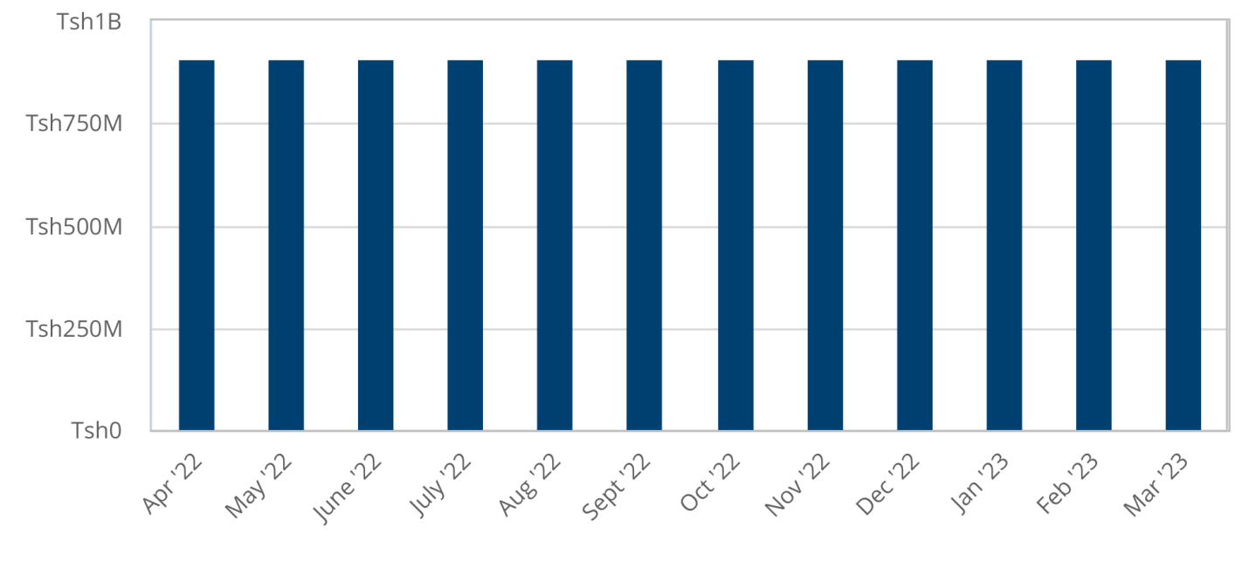

Expenses by Month
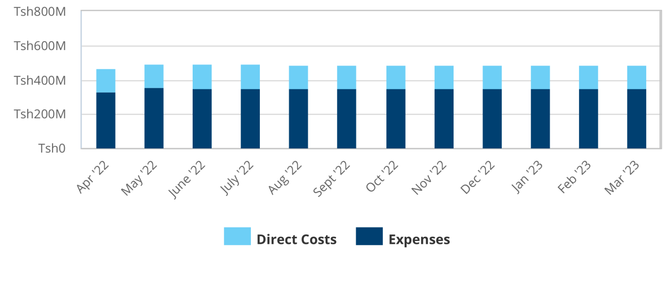

CONFIDENTIAL - DO NOT DISSEMINATE. This business plan contains confidential, trade-secret information and is shared only with the understanding that you will not share its contents or ideas with third parties without the express written consent of the plan author.

MAISHA TRANSPORT COMPANY LIMITED 14
Net Profit (or Loss) by Year
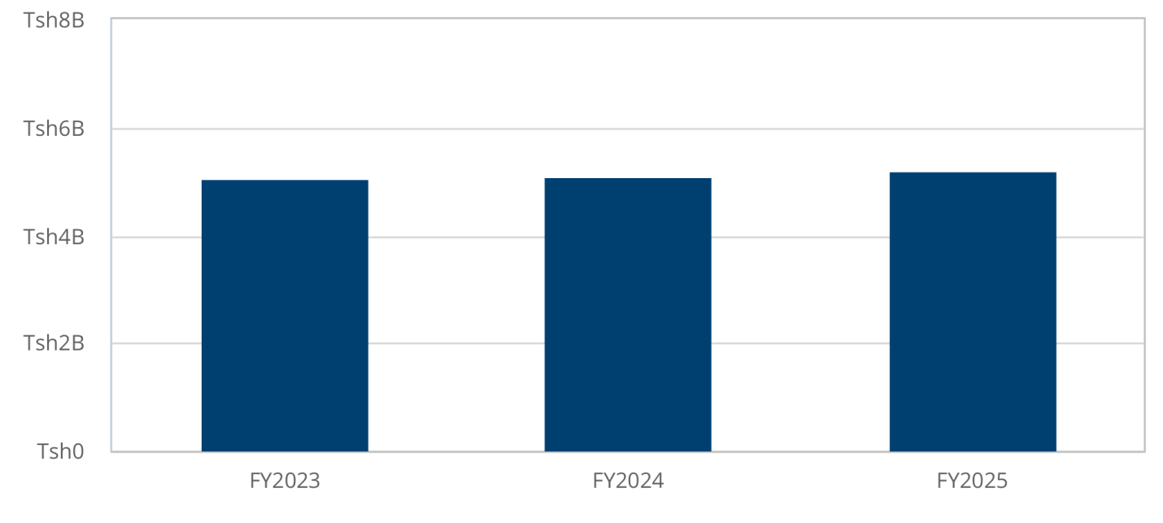

CONFIDENTIAL - DO NOT DISSEMINATE. This business plan contains confidential, trade-secret information and is shared only with the understanding that you will not share its contents or ideas with third parties without the express written consent of the plan author.

MAISHA TRANSPORT COMPANY LIMITED 15

Financing
Sources of Funds

Statements
Projected Profit and Loss

FY2023 |  | FY2024 | FY2025
Revenue | Tsh10,908,849,600 | Tsh10,908,849,600 | Tsh10,908,849,600
Direct Costs | Tsh1,642,977,600 | Tsh1,681,857,600 | Tsh1,722,681,600

including all compliance charges
fuel and lubicants | Tsh1,408,029,096 | Tsh1,408,029,096 | Tsh1,408,029,096
Business license & other Levy | Tsh3,800,000 | Tsh3,800,000 | Tsh3,800,000
fees for consultation services | Tsh12,514,585 | Tsh12,514,585 | Tsh12,514,585
road toll & charges | Tsh40,770,000 | Tsh40,770,000 | Tsh40,770,000
Spare parts & lubricants | Tsh234,584,628 | Tsh234,584,628 | Tsh234,584,628
transport allowance | Tsh141,240,000 | Tsh141,240,000 | Tsh141,240,000
Total Operating Expenses | Tsh2,308,250,901 | Tsh2,308,250,901 | Tsh2,308,250,901
Operating Income | Tsh6,957,621,099 | Tsh6,918,741,099 | Tsh6,877,917,099
Interest Incurred | Tsh276,863,858 | Tsh172,089,783 | Tsh2,629,587
Depreciation and Amortization | Tsh519,168,977 | Tsh519,168,977 | Tsh519,168,977
Gain or Loss from Sale of Assets
Income Taxes | Tsh1,109,085,887 | Tsh1,120,946,821 | Tsh1,144,101,337
Total Expenses | Tsh5,856,347,223 | Tsh5,802,314,082 | Tsh5,696,832,402

CONFIDENTIAL - DO NOT DISSEMINATE. This business plan contains confidential, trade-secret information and is shared only with the understanding that you will not share its contents or ideas with third parties without the express written consent of the plan author.

MAISHA TRANSPORT COMPANY LIMITED 16

Net Profit | Tsh5,052,502,377 | Tsh5,106,535,518 | Tsh5,212,017,198
Net Profit / Sales | 46% | 47% | 48%

CONFIDENTIAL - DO NOT DISSEMINATE. This business plan contains confidential, trade-secret information and is shared only with the understanding that you will not share its contents or ideas with third parties without the express written consent of the plan author.

MAISHA TRANSPORT COMPANY LIMITED 17

Projected Balance Sheet
 | FY2023 | FY2024 | FY2025
Cash | Tsh4,967,300,577 | Tsh10,401,164,190 | Tsh16,119,618,486
Accounts Receivable Inventory  Other Current Assets  Total Current Assets | Tsh0  Tsh4,967,300,577 | Tsh0  Tsh10,401,164,190 | Tsh0  Tsh16,119,618,486
Long-Term Assets | Tsh2,595,844,885 | Tsh2,595,844,885 | Tsh2,595,844,885
Accumulated Depreciation | (Tsh519,168,977) | (Tsh1,038,337,954) | (Tsh1,557,506,931)
Total Long-Term Assets | Tsh2,076,675,908 | Tsh1,557,506,931 | Tsh1,038,337,954
Total Assets | Tsh7,043,976,485 | Tsh11,958,671,121 | Tsh17,157,956,440
Accounts Payable | Tsh0 | Tsh0 | Tsh0
Income Taxes Payable | Tsh1,109,085,887 | Tsh1,120,946,821 | Tsh1,144,101,337
Sales Taxes Payable | Tsh0 | Tsh0 | Tsh0
Short-Term Debt | Tsh203,701,821 | Tsh28,686,406 | Tsh10
Prepaid Revenue  Total Current Liabilities | Tsh1,312,787,708 | Tsh1,149,633,227 | Tsh1,144,101,347
Long-Term Debt | Tsh28,686,401 | Tsh0 | Tsh0
Long-Term Liabilities | Tsh28,686,401 | Tsh0 | Tsh0
Total Liabilities | Tsh1,341,474,108 | Tsh1,149,633,227 | Tsh1,144,101,347
Paid-In Capital Retained Earnings Earnings | Tsh650,000,000  Tsh5,052,502,377 | Tsh650,000,000 Tsh5,052,502,377 Tsh5,106,535,518 | Tsh650,000,000 Tsh10,151,837,894 Tsh5,212,017,198
Total Owner's Equity | Tsh5,702,502,377 | Tsh10,809,037,894 | Tsh16,013,855,092
Total Liabilities & Equity | Tsh7,043,976,485 | Tsh11,958,671,121 | Tsh17,157,956,440

CONFIDENTIAL - DO NOT DISSEMINATE. This business plan contains confidential, trade-secret information and is shared only with the understanding that you will not share its contents or ideas with third parties without the express written consent of the plan author.

MAISHA TRANSPORT COMPANY LIMITED 18

Projected Cash Flow Statement
 | FY2023 | FY2024 | FY2025
Net Cash Flow from Operations
Net Profit | Tsh5,052,502,377 | Tsh5,106,535,518 | Tsh5,212,017,198
Depreciation & Amortization | Tsh519,168,977 | Tsh519,168,977 | Tsh519,168,977
Change in Accounts Receivable | Tsh0 | Tsh0 | Tsh0
Change in Inventory
Change in Accounts Payable | Tsh0 | Tsh0 | Tsh0
Change in Income Tax Payable | Tsh1,109,085,887 | Tsh11,860,934 | Tsh23,154,516
Change in Sales Tax Payable | Tsh0 | Tsh0 | Tsh0
Change in Prepaid Revenue
Net Cash Flow from Operations | Tsh6,680,757,241 | Tsh5,637,565,429 | Tsh5,754,340,691
Investing & Financing
Assets Purchased or Sold | (Tsh2,595,844,885)
Net Cash from Investing | (Tsh2,595,844,885)
Investments Received | Tsh650,000,000
Dividends & Distributions |  |  | (Tsh7,200,000)
Change in Short-Term Debt | Tsh203,701,821 | (Tsh175,015,415) | (Tsh28,686,395)
Change in Long-Term Debt | Tsh28,686,401 | (Tsh28,686,401) | Tsh0
Net Cash from Financing | Tsh882,388,221 | (Tsh203,701,816) | (Tsh35,886,395)
Cash at Beginning of Period | Tsh0 | Tsh4,967,300,577 | Tsh10,401,164,190
Net Change in Cash | Tsh4,967,300,577 | Tsh5,433,863,613 | Tsh5,718,454,296
Cash at End of Period | Tsh4,967,300,577 | Tsh10,401,164,190 | Tsh16,119,618,486

CONFIDENTIAL - DO NOT DISSEMINATE. This business plan contains confidential, trade-secret information and is shared only with the understanding that you will not share its contents or ideas with third parties without the express written consent of the plan author.

MAISHA TRANSPORT COMPANY LIMITED 19

Appendix
Profit and Loss Statement (With monthly detail)

 | Jul-2025 | Aug-2025 | Sep-2025 | Oct-2025 | Nov-2025 | Dec-2025 | Jan-2026 | Feb-2026 | Mar-2026 | Apr-2026 | May-2026 | Jun-2026
Total Turnover | 3,332,827,553 | 3,332,827,553 | 3,332,827,553 | 3,332,827,553 | 3,332,827,553 | 3,332,827,553 | 3,332,827,553 | 3,332,827,553 | 3,332,827,553 | 3,332,827,553 | 3,332,827,553 | 3,332,827,553
Total Cost of Sales | 1,999,696,532 | 1,999,696,532 | 1,999,696,532 | 1,999,696,532 | 1,999,696,532 | 1,999,696,532 | 1,999,696,532 | 1,999,696,532 | 1,999,696,532 | 1,999,696,532 | 1,999,696,532 | 1,999,696,532
Total Gross Profit | 1,333,131,021 | 1,333,131,021 | 1,333,131,021 | 1,333,131,021 | 1,333,131,021 | 1,333,131,021 | 1,333,131,021 | 1,333,131,021 | 1,333,131,021 | 1,333,131,021 | 1,333,131,021 | 1,333,131,021
Gross Profit % | 40.0% | 40.0% | 40.0% | 40.0% | 40.0% | 40.0% | 40.0% | 40.0% | 40.0% | 40.0% | 40.0% | 40.0%
Total Operating Expenses | 8,800,000 | 8,800,000 | 8,800,000 | 8,800,000 | 8,800,000 | 8,800,000 | 8,800,000 | 8,800,000 | 8,800,000 | 8,800,000 | 8,800,000 | 8,800,000
Production Costs
Sales & Marketing | 56,318,536 | 56,318,536 | 56,318,536 | 56,318,536 | 56,318,536 | 56,318,536 | 56,318,536 | 56,318,536 | 56,318,536 | 56,318,536 | 56,318,536 | 56,318,536
Production | 78,567,383 | 78,567,383 | 78,567,383 | 78,567,383 | 78,567,383 | 78,567,383 | 78,567,383 | 78,567,383 | 78,567,383 | 78,567,383 | 78,567,383 | 78,567,383
Total Production Costs | 134,885,919 | 134,885,919 | 134,885,919 | 134,885,919 | 134,885,919 | 134,885,919 | 134,885,919 | 134,885,919 | 134,885,919 | 134,885,919 | 134,885,919 | 134,885,919
Profit / (Loss) before Interest & Tax | 1,189,445,102 | 1,189,445,102 | 1,189,445,102 | 1,189,445,102 | 1,189,445,102 | 1,189,445,102 | 1,189,445,102 | 1,189,445,102 | 1,189,445,102 | 1,189,445,102 | 1,189,445,102 | 1,189,445,102
Total Interest Paid | 71,978,080 | 71,096,748 | 70,206,603 | 69,307,556 | 68,399,519 | 67,482,402 | 66,556,113 | 65,620,562 | 64,675,655 | 63,721,299 | 62,757,399 | 61,783,860
Profit / (Loss) before tax | 1,117,467,022 | 1,118,348,354 | 1,119,238,499 | 1,120,137,546 | 1,121,045,583 | 1,121,962,700 | 1,122,888,989 | 1,123,824,540 | 1,124,769,447 | 1,125,723,804 | 1,126,687,703 | 1,127,661,242
Taxation | 335,240,107 | 335,504,506 | 335,771,550 | 336,041,264 | 336,313,675 | 336,588,810 | 336,866,697 | 337,147,362 | 337,430,834 | 337,717,141 | 338,006,311 | 338,298,373
Profit / (Loss) for the year | 782,226,916 | 782,843,848 | 783,466,949 | 784,096,282 | 784,731,908 | 785,373,890 | 786,022,292 | 786,677,178 | 787,338,613 | 788,006,662 | 788,681,392 | 789,362,869
Dividends | - | - | - | - | - | - | - | - | - | - | - | 1,980,054,048
Retained earnings for the year | 782,226,916 | 782,843,848 | 783,466,949 | 784,096,282 | 784,731,908 | 785,373,890 | 786,022,292 | 786,677,178 | 787,338,613 | 788,006,662 | 788,681,392 | (1,190,691,179)
Profit / (Loss) % | 23.5% | 23.5% | 23.5% | 23.5% | 23.5% | 23.6% | 23.6% | 23.6% | 23.6% | 23.6% | 23.7% | 23.7%

Operating Expenses
Salaries and Wages
Employee Related Expenses
Rental charges Marketing
Other operating expenses including all compliance charges
fuel and lubicants

Tsh24,000,000 Tsh24,000,000 Tsh24,000,000 Tsh24,000,000 Tsh24,000,000 Tsh24,000,000 Tsh24,000,000 Tsh24,000,000 Tsh24,000,000 Tsh24,000,000 Tsh24,000,000 Tsh24,000,000

Tsh3,500,000 Tsh3,500,000 | Tsh3,500,000 Tsh3,500,000 | Tsh3,500,000 Tsh3,500,000 | Tsh3,500,000 Tsh3,500,000 | Tsh3,500,000 Tsh3,500,000 | Tsh3,500,000 Tsh3,500,000 | Tsh3,500,000 Tsh3,500,000 | Tsh3,500,000 Tsh3,500,000 | Tsh3,500,000 Tsh3,500,000 | Tsh3,500,000 Tsh3,500,000 | Tsh3,500,000 Tsh3,500,000 | Tsh3,500,000 Tsh3,500,000
Tsh7,942,716 | Tsh7,942,716 | Tsh7,942,716 | Tsh7,942,716 | Tsh7,942,716 | Tsh7,942,716 | Tsh7,942,716 | Tsh7,942,716 | Tsh7,942,716 | Tsh7,942,716 | Tsh7,942,716 | Tsh7,942,716
Tsh117,335,758 | Tsh117,335,758 | Tsh117,335,758 | Tsh117,335,758 | Tsh117,335,758 | Tsh117,335,758 | Tsh117,335,758 | Tsh117,335,758 | Tsh117,335,758 | Tsh117,335,758 | Tsh117,335,758 | Tsh117,335,758

CONFIDENTIAL - DO NOT DISSEMINATE. This business plan contains confidential, trade-secret information and is shared only with the understanding that you will not share its contents or ideas with third parties without the express written consent of the plan author.

MAISHA TRANSPORT COMPANY LIMITED 20

Business

charges

lubricants

allowance

Expenses

Amortization

Gain or Loss from Sale of Assets

Sales

CONFIDENTIAL - DO NOT DISSEMINATE. This business plan contains confidential, trade-secret information and is shared only with the understanding that you will not share its contents or ideas with third parties without the express written consent of the plan author.

MAISHA TRANSPORT COMPANY LIMITED 21

FY2023 |  | FY2024 | FY2025
Total Revenue | Tsh10,908,849,600 | Tsh10,908,849,600 | Tsh10,908,849,600
Total Direct Costs | Tsh1,642,977,600 | Tsh1,681,857,600 | Tsh1,722,681,600

Gross Margin | Tsh9,265,872,000 | Tsh9,226,992,000 | Tsh9,186,168,000
Gross Margin % | 85% | 85% | 84%
Operating Expenses
Salaries and Wages | Tsh288,000,000 | Tsh288,000,000 | Tsh288,000,000
Employee Related Expenses
Rental charges | Tsh42,000,000 | Tsh42,000,000 | Tsh42,000,000
Marketing | Tsh42,000,000 | Tsh42,000,000 | Tsh42,000,000
Other operating expenses including all compliance charges | Tsh95,312,592 | Tsh95,312,592 | Tsh95,312,592
fuel and lubicants | Tsh1,408,029,096 | Tsh1,408,029,096 | Tsh1,408,029,096
Business license & other Levy | Tsh3,800,000 | Tsh3,800,000 | Tsh3,800,000
fees for consultation services | Tsh12,514,585 | Tsh12,514,585 | Tsh12,514,585
road toll & charges | Tsh40,770,000 | Tsh40,770,000 | Tsh40,770,000
Spare parts & lubricants | Tsh234,584,628 | Tsh234,584,628 | Tsh234,584,628
transport allowance | Tsh141,240,000 | Tsh141,240,000 | Tsh141,240,000
Total Operating Expenses | Tsh2,308,250,901 | Tsh2,308,250,901 | Tsh2,308,250,901
Operating Income | Tsh6,957,621,099 | Tsh6,918,741,099 | Tsh6,877,917,099
Interest Incurred | Tsh276,863,858 | Tsh172,089,783 | Tsh2,629,587
Depreciation and Amortization | Tsh519,168,977 | Tsh519,168,977 | Tsh519,168,977
Gain or Loss from Sale of Assets
Income Taxes | Tsh1,109,085,887 | Tsh1,120,946,821 | Tsh1,144,101,337
Total Expenses | Tsh5,856,347,223 | Tsh5,802,314,082 | Tsh5,696,832,402
Net Profit | Tsh5,052,502,377 | Tsh5,106,535,518 | Tsh5,212,017,198
Net Profit / Sales | 46% | 47% | 48%

CONFIDENTIAL - DO NOT DISSEMINATE. This business plan contains confidential, trade-secret information and is shared only with the understanding that you will not share its contents or ideas with third parties without the express written consent of the plan author.

MAISHA TRANSPORT COMPANY LIMITED 22

CONFIDENTIAL - DO NOT DISSEMINATE. This business plan contains confidential, trade-secret information and is shared only with the understanding that you will not share its contents or ideas with third parties without the express written consent of the plan author.

MAISHA TRANSPORT COMPANY LIMITED 23
Balance Sheet (With Monthly Detail)

Cash

Accounts Receivable
Inventory

Other Current Assets

Payable

Income Taxes Payable

Tsh96,576,782 Tsh188,203,564 Tsh279,893,309 Tsh371,651,790 Tsh463,485,306 Tsh555,400,736 Tsh647,405,590 Tsh739,508,063 Tsh831,717,104 Tsh924,042,483 Tsh1,016,494,8
64

Tsh1,109,085,8
87

Sales Taxes Payable
Short-Term Debt
Prepaid Revenue

Tsh0 Tsh0 Tsh0 Tsh0 Tsh0 Tsh0 Tsh0 Tsh0 Tsh0 Tsh0 Tsh0 Tsh0

Tsh77,625,492 Tsh84,741,162 Tsh92,509,102 Tsh100,989,103 Tsh110,246,437 Tsh120,352,361 Tsh131,384,660 Tsh143,428,254 Tsh156,575,844 Tsh170,928,630 Tsh186,597,088 Tsh203,701,821

Total Current Liabilities
Tsh174,202,2
74
Tsh272,944,7
26
Tsh372,402,4
11
Tsh472,640,8
93
Tsh573,731,7
43
Tsh675,753,0
97
Tsh778,790,2
50
Tsh882,936,3
17
Tsh988,292,9
48
Tsh1,094,971
,113
Tsh1,203,091
,952
Tsh1,312,787
,708

CONFIDENTIAL - DO NOT DISSEMINATE. This business plan contains confidential, trade-secret information and is shared only with the understanding that you will not share its contents or ideas with third parties without the express written consent of the plan author.

MAISHA TRANSPORT COMPANY LIMITED 24

Long-Term Debt
Tsh222,374,508 Tsh211,442,871 Tsh199,509,167 Tsh186,481,540 Tsh172,259,715 Tsh156,734,222 Tsh139,785,558 Tsh121,283,267 Tsh101,084,933 Tsh79,035,085 Tsh54,964,001 Tsh28,686,401

Long-Term Liabilities
Tsh222,374,5
08
Tsh211,442,8
71
Tsh199,509,1
67
Tsh186,481,5
40
Tsh172,259,7
15
Tsh156,734,2
22
Tsh139,785,5
58
Tsh121,283,2
67
Tsh101,084,9
33
Tsh79,035,08
5
Tsh54,964,00
1
Tsh28,686,40
1

Paid-In Capital Tsh650,000,000 Tsh650,000,000 Tsh650,000,000 Tsh650,000,000 Tsh650,000,000 Tsh650,000,000 Tsh650,000,000 Tsh650,000,000 Tsh650,000,000 Tsh650,000,000 Tsh650,000,000 Tsh650,000,000
Retained Earnings

Earnings Tsh439,960,896 Tsh857,371,791 Tsh1,275,069,5
21
Tsh1,693,080,3
76
Tsh2,111,433,0
61
Tsh2,530,158,9
10
Tsh2,949,292,1
29
Tsh3,368,870,0
63
Tsh3,788,933,4
76
Tsh4,209,526,8
69
Tsh4,630,698,8
24
Tsh5,052,502,3
77

CONFIDENTIAL - DO NOT DISSEMINATE. This business plan contains confidential, trade-secret information and is shared only with the understanding that you will not share its contents or ideas with third parties without the express written consent of the plan author.

MAISHA TRANSPORT COMPANY LIMITED 25

 | FY2023 | FY2024 | FY2025
Cash | Tsh4,967,300,577 | Tsh10,401,164,190 | Tsh16,119,618,486
Accounts Receivable Inventory  Other Current Assets  Total Current Assets | Tsh0  Tsh4,967,300,577 | Tsh0  Tsh10,401,164,190 | Tsh0  Tsh16,119,618,486
Long-Term Assets | Tsh2,595,844,885 | Tsh2,595,844,885 | Tsh2,595,844,885
Accumulated Depreciation | (Tsh519,168,977) | (Tsh1,038,337,954) | (Tsh1,557,506,931)
Total Long-Term Assets | Tsh2,076,675,908 | Tsh1,557,506,931 | Tsh1,038,337,954
Total Assets | Tsh7,043,976,485 | Tsh11,958,671,121 | Tsh17,157,956,440
Accounts Payable | Tsh0 | Tsh0 | Tsh0
Income Taxes Payable | Tsh1,109,085,887 | Tsh1,120,946,821 | Tsh1,144,101,337
Sales Taxes Payable | Tsh0 | Tsh0 | Tsh0
Short-Term Debt | Tsh203,701,821 | Tsh28,686,406 | Tsh10
Prepaid Revenue  Total Current Liabilities | Tsh1,312,787,708 | Tsh1,149,633,227 | Tsh1,144,101,347
Long-Term Debt | Tsh28,686,401 | Tsh0 | Tsh0
Long-Term Liabilities | Tsh28,686,401 | Tsh0 | Tsh0
Total Liabilities | Tsh1,341,474,108 | Tsh1,149,633,227 | Tsh1,144,101,347
Paid-In Capital Retained Earnings Earnings | Tsh650,000,000  Tsh5,052,502,377 | Tsh650,000,000 Tsh5,052,502,377 Tsh5,106,535,518 | Tsh650,000,000 Tsh10,151,837,894 Tsh5,212,017,198
Total Owner's Equity | Tsh5,702,502,377 | Tsh10,809,037,894 | Tsh16,013,855,092
Total Liabilities & Equity | Tsh7,043,976,485 | Tsh11,958,671,121 | Tsh17,157,956,440

CONFIDENTIAL - DO NOT DISSEMINATE. This business plan contains confidential, trade-secret information and is shared only with the understanding that you will not share its contents or ideas with third parties without the express written consent of the plan author.

MAISHA TRANSPORT COMPANY LIMITED 26

Cash Flow Statement (With Monthly Detail)

Amortization

Receivable

Change in Inventory
Change in

Payable

Operations
Investing & Financing
Assets Purchased or Sold

(Tsh2,595,844
,885)

CONFIDENTIAL - DO NOT DISSEMINATE. This business plan contains confidential, trade-secret information and is shared only with the understanding that you will not share its contents or ideas with third parties without the express written consent of the plan author.

MAISHA TRANSPORT COMPANY LIMITED 27

Investments Received
Dividends & Distributions

Tsh650,000,0
00

Debt

Debt

Financing

Period

Cash 26)

CONFIDENTIAL - DO NOT DISSEMINATE. This business plan contains confidential, trade-secret information and is shared only with the understanding that you will not share its contents or ideas with third parties without the express written consent of the plan author.

MAISHA TRANSPORT COMPANY LIMITED 28

 | FY2023 | FY2024 | FY2025
Net Cash Flow from Operations
Net Profit | Tsh5,052,502,377 | Tsh5,106,535,518 | Tsh5,212,017,198
Depreciation & Amortization | Tsh519,168,977 | Tsh519,168,977 | Tsh519,168,977
Change in Accounts Receivable | Tsh0 | Tsh0 | Tsh0
Change in Inventory
Change in Accounts Payable | Tsh0 | Tsh0 | Tsh0
Change in Income Tax Payable | Tsh1,109,085,887 | Tsh11,860,934 | Tsh23,154,516
Change in Sales Tax Payable | Tsh0 | Tsh0 | Tsh0
Change in Prepaid Revenue
Net Cash Flow from Operations | Tsh6,680,757,241 | Tsh5,637,565,429 | Tsh5,754,340,691
Investing & Financing
Assets Purchased or Sold | (Tsh2,595,844,885)
Net Cash from Investing | (Tsh2,595,844,885)
Investments Received | Tsh650,000,000
Dividends & Distributions |  |  | (Tsh7,200,000)
Change in Short-Term Debt | Tsh203,701,821 | (Tsh175,015,415) | (Tsh28,686,395)
Change in Long-Term Debt | Tsh28,686,401 | (Tsh28,686,401) | Tsh0
Net Cash from Financing | Tsh882,388,221 | (Tsh203,701,816) | (Tsh35,886,395)
Cash at Beginning of Period | Tsh0 | Tsh4,967,300,577 | Tsh10,401,164,190
Net Change in Cash | Tsh4,967,300,577 | Tsh5,433,863,613 | Tsh5,718,454,296
Cash at End of Period | Tsh4,967,300,577 | Tsh10,401,164,190 | Tsh16,119,618,486

CONFIDENTIAL - DO NOT DISSEMINATE. This business plan contains confidential, trade-secret information and is shared only with the understanding that you will not share its contents or ideas with third parties without the express written consent of the plan author.

